**Mascot design ideas-Jordan marks**

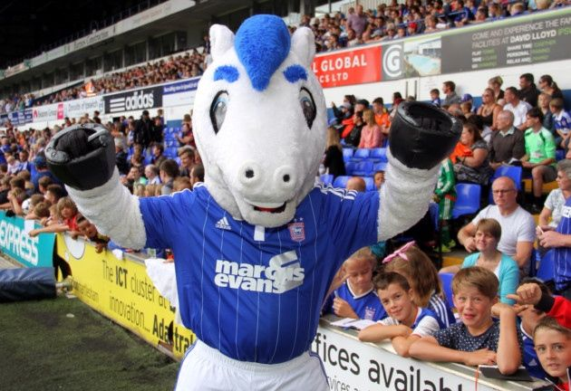Ipswich town FC- **Horse**

We could use the Ipswich town mascot. As that would be well knew in the town.

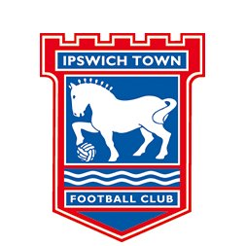

I have also looked at a number of different art styles we could use and different ways we could position the horse for animation and such.

We could something like they do here with the horse being very carton like to keep it family friendly

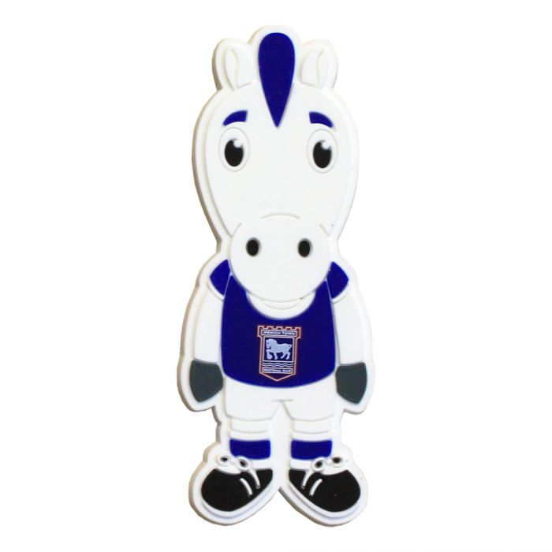









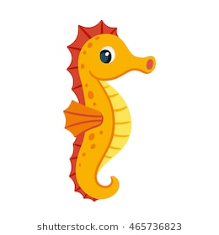Ipswich borough council – **Seahorse**



We could also use the Seahorse on the Ipswich borough council logo as that has some historical important for the town. We could do a side view of the seahorse looking at the player or try to do it face on like the horse. We could use a number of different arts styles like I have seen above.

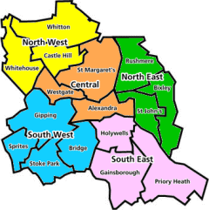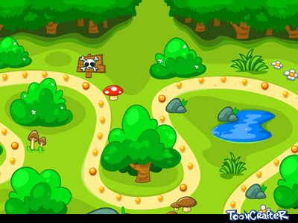**Map design ideas-Jordan marks**

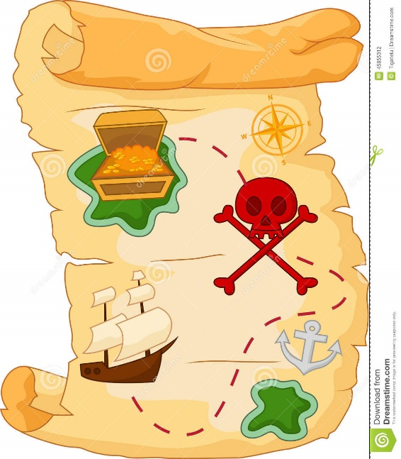

The map like we discussed could be like a treasure map, this would work well with the digging aspect of the game. Yet I feel that a map laid out with a number of “dig sites” would work best. We could evening divide the areas up into IP address like the museum has said.

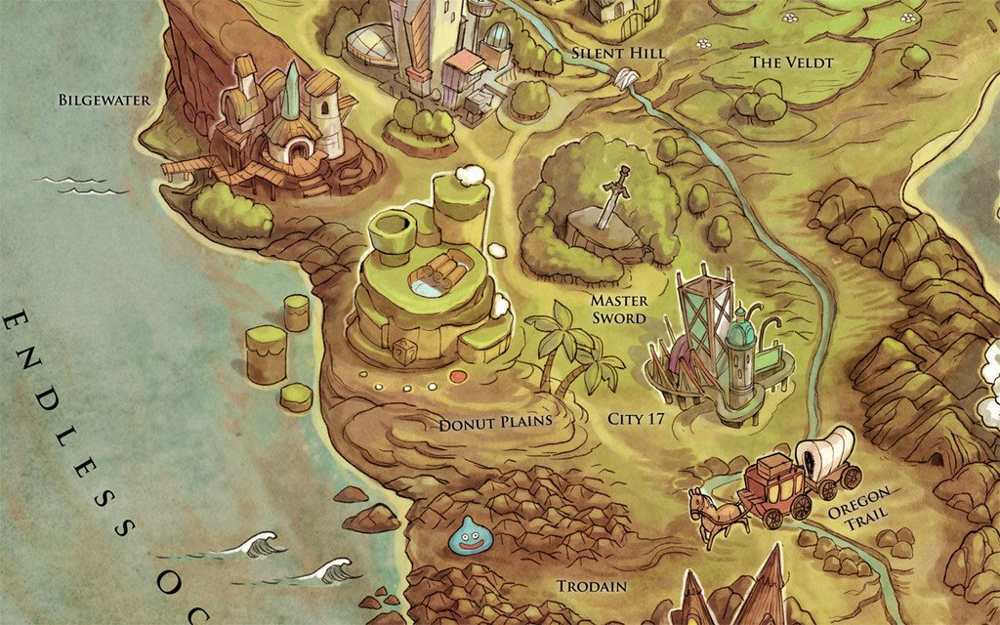 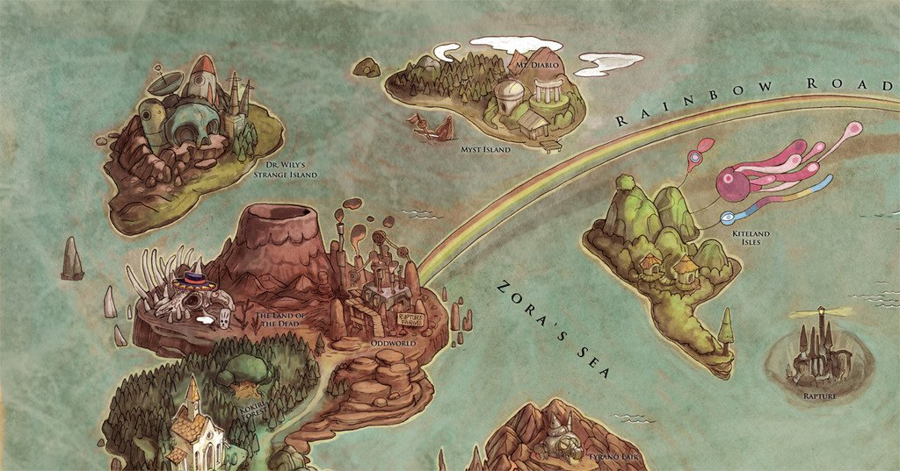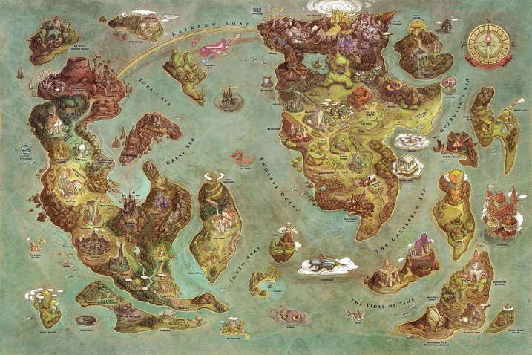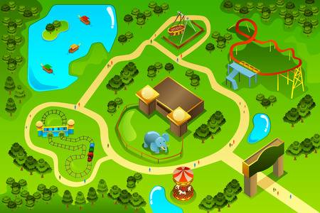

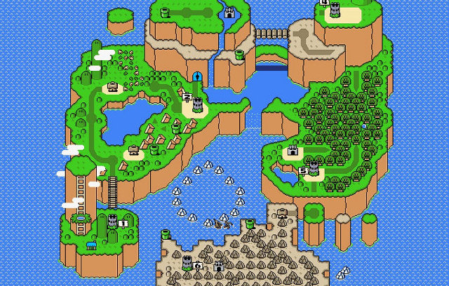

The map art style could be a number of different ones. We could do the pixel art route yet I feel that does not have the details we need to show clearly. Yet I don’t think the more complex map would be any more helpful. We need to find a happy middle ground to show a level of details for adults yet keep it child friendly.

References:

Dribbble. (2018). Forest Map - Game Scenario Select. [online] Available at: https://dribbble.com/shots/1818919-Forest-Map-Game-Scenario-Select [Accessed 4 Jul. 2018].

Encrypted-tbn0.gstatic.com. (2017). [online] Available at: https://encrypted-tbn0.gstatic.com/images?q=tbn:ANd9GcQfFZGL1hRUeQz-o3CquLAqdDVdisYntlZErKBZJTGnkcg0qLhx

Encrypted-tbn0.gstatic.com. (2017). [online] Available at: https://encrypted-tbn0.gstatic.com/images?q=tbn:ANd9GcQS7YX6UHjamm3NhvCKTGADb-bvdqpjipokuA43AOIW_JQzCq9XfQ

Encrypted-tbn0.gstatic.com. (2017). [online] Available at: https://encrypted-tbn0.gstatic.com/images?q=tbn:ANd9GcQTbJO6lfPChmWDyJu9c-iGH9g6GWcRb5lI-6jRU1g8tVQ-7MyQPQ

Encrypted-tbn0.gstatic.com. (2017). [online] Available at: https://encrypted-tbn0.gstatic.com/images?q=tbn:ANd9GcRTC1KLKO-QCcN0BX9a2dyeSoRWjpsze0-VfErRjVyveUDJbuJy5g [Accessed 4 Jul. 2018].

Foster-douglas.com. (2017). Foster Douglas – 755 Defining Video Game Map Types. [online] Available at: <http://www.foster-douglas.com/games/755-defining-video-game-map-types/>

Itfcshop.com. (2017). [online] Available at: https://itfcshop.com/media/catalog/product/cache/c687aa7517cf01e65c009f6943c2b1e9/3/1/31646.jpg

Image.shutterstock.com. (2017). [online] Available at: https://image.shutterstock.com/image-vector/cute-horse-cartoon-260nw-549078133.jpg

Image.shutterstock.com. (2017). [online] Available at: https://image.shutterstock.com/image-vector/cute-cartoon-orange-seahorse-isolated-260nw-465736823.jpg

Img.clipartxtras.com. (2018). [online] Available at: https://img.clipartxtras.com/44c12ff130e5d962870adad49e38f1ee_how-to-draw-a-seahorse-easy-step-by-step-drawing-tutorial-small-seahorse-drawing_215-382.png [Accessed 4 Jul. 2018].

I.pinimg.com. (2017). [online] Available at: https://i.pinimg.com/736x/b4/55/0c/b4550c84db2e344e6c9689ccbc7c72bc--ipswich-town-fifa-.jpg

I.pinimg.com. (2018). [online] Available at: https://i.pinimg.com/736x/45/98/fe/4598fe692b3eefb22068214614c17168--paper-templates-vbs-.jpg

Ipswich.gov.uk. (2017). [online] Available at: https://www.ipswich.gov.uk/sites/www.ipswich.gov.uk/files/area_forums_map.gif

Kotaku Australia. (2015). The Video Game Map To End All Video Game Maps. [online] Available at: https://www.kotaku.com.au/2015/07/the-video-game-map-to-end-all-video-game-maps/

map, C. (2017). Cartoon Treasure map stock vector. Illustration of spooky - 45855312. [online] Dreamstime.com. Available at: https://www.dreamstime.com/stock-illustration-cartoon-treasure-map-illustration-image45855312

Pbs.twimg.com. (2017). [online] Available at: https://pbs.twimg.com/profile_images/954337262204006400/ifE1fK80_400x400

Pbs.twimg.com. (2017). [online] Available at: https://pbs.twimg.com/profile_images/575578462003466240/pOQGjbnn_400x400.png [Accessed 4 Jul. 2018].

123RF Stock Photos. (2017). A vector illustration of map of an amusement theme park. [online] Available at: https://www.123rf.com/photo_33923158_stock-vector-a-vector-illustration-of-map-of-an-amusement-theme-park.html

123RF Stock Photos. (2017). Cartoon map seamless pattern of small town and countryside.. [online] Available at: https://www.123rf.com/photo_15566600_cartoon-map-seamless-pattern-of-small-town-and-countryside-.html